**Pattern classification** is a fundamental concept in machine learning and artificial intelligence, where the goal is to assign a category label to a given input pattern.

### Answer:

**Pattern Classification** **is the process of categorizing input data into predefined classes based on key features.** It is crucial in various applications like image recognition, character recognition, vowels recognition and medical diagnosis.

### Steps of Pattern Classification:

1. **Data Collection**: Gather a large set of labelled data, representing different classes.

2. **Feature Extraction**: Identify and extract relevant features from the raw data that will help in distinguishing between classes.

3. **Model Selection**: Choose an appropriate classification algorithm (e.g., Decision Trees, Support Vector Machines, Neural Networks).

4. **Training**: Use the labelled dataset to train the selected model, adjusting parameters to minimize classification errors.

5. **Evaluation**: Assess the model’s performance using a separate validation set, employing metrics like accuracy, precision, and recall.

6. **Testing and Deployment**: Test the model with new, unseen data to ensure generalization, and deploy it for real-world application.

This process ensures that the model can accurately classify new input patterns based on the learned features and patterns from the training data.

### Example:

Consider an image recognition task where the goal is to classify images of cats and dogs. The steps would include collecting a dataset of labelled images, extracting features such as edges and textures, training a neural network on this dataset, evaluating its performance, and finally using it to classify new images of cats and dogs.

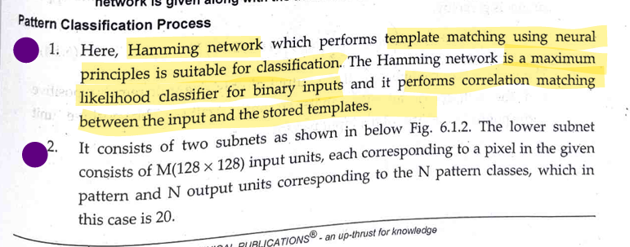

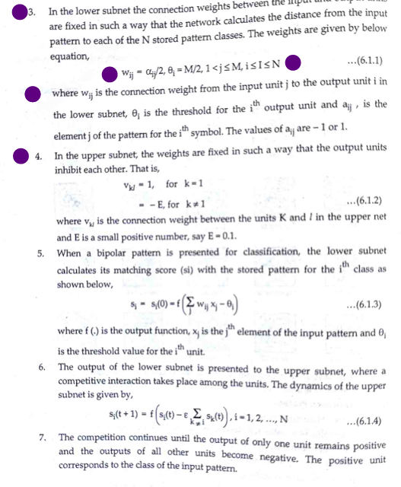

Artificial Neural Networks (ANNs) play a crucial role in pattern classification and recognition, particularly in complex tasks such as recognizing Olympic game symbols. Here’s an in-depth discussion on their application in this domain:

### **Introduction to ANN and Pattern Recognition**

Artificial Neural Networks (ANNs) are computational models inspired by the human brain’s neural networks. They are particularly well-suited for tasks involving pattern recognition and classification due to their ability to learn from data, identify patterns, and make decisions based on input features. Pattern classification involves categorizing input data into predefined classes, while pattern recognition is about identifying patterns and regularities in data.

**### Application of ANN in Recognizing Olympic Game Symbols**

1. **Data Collection and Preprocessing**:

- **Dataset Creation**: To train an ANN for recognizing Olympic game symbols, a comprehensive dataset of images representing each symbol is required. This dataset should include various transformations, rotations, and scales of the symbols to enhance the network's robustness.

- **Preprocessing**: This step involves normalizing the images, converting them to grayscale if necessary, and resizing them to a uniform size. Techniques like edge detection or noise reduction might also be applied to improve the quality of the input data.

**2. **Network Architecture**:**

- **Input Layer**: **The input layer of the ANN corresponds to the pixel values of the pre-processed images.**

- \*\***Hidden** **Layers**\*\*: These layers perform **feature extraction by learning hierarchical patterns** from the input data. **Convolutional Neural Networks (CNNs)**, a type of ANN, are particularly effective for **image recognition tasks due to their ability to capture spatial hierarchies** in images.

- **Output Layer**: The output layer **has neurons equal to the number of classes** (i.e., the number of different Olympic symbols). Each neuron **represents the probability** of the input image belonging to a specific class.

3. **Training the Network**:

- **Supervised Learning**: The ANN is trained using a labeled dataset where each image is associated with a specific Olympic symbol. During training, the network adjusts its weights to minimize the difference between its predictions and the actual labels.

- **Backpropagation and Optimization**: Techniques like backpropagation are used to compute the gradient of the loss function with respect to the weights, and optimization algorithms like Adam or SGD are used to update the weights.

4. **Evaluation and Validation**:

- **Accuracy Assessment**: The performance of the trained ANN is evaluated using metrics such as accuracy, precision, recall, and F1-score on a separate validation set.

- **Cross-Validation**: Techniques like k-fold cross-validation ensure that the model generalizes well to unseen data and is not overfitting the training dataset.

5. **Deployment and Real-time Recognition**:

- **Real-time Application**: Once trained, the ANN can be deployed in real-time systems to classify and recognize Olympic game symbols from live feeds or static images.

- **Performance Optimization**: Techniques such as model pruning, quantization, and utilizing specialized hardware (like GPUs or TPUs) can be employed to enhance the inference speed and efficiency of the ANN in real-time applications.

### **Advantages** of Using ANN for Olympic Symbol Recognition

1. **High Accuracy**: ANNs, especially deep learning models like CNNs, provide high accuracy in image classification tasks due to their ability to learn complex patterns.

2. **Robustness**: Well-trained ANNs can handle variations in symbol size, orientation, and lighting conditions, making them robust against real-world scenarios.

3. **Scalability**: ANNs can be scaled to recognize a large number of symbols and can be retrained with additional data to improve performance or adapt to new symbols.

### **Challenges** and Considerations

1. **Data Requirements**: ANNs require large amounts of labeled data for training, which can be challenging to obtain for all possible variations of Olympic symbols.

2. **Computational Resources**: Training and deploying ANNs, particularly deep networks, require significant computational resources, which may not be readily available in all settings.

3. **Interpretability**: ANNs are often seen as "black boxes," making it difficult to interpret the decision-making process, which can be a concern in critical applications.

### Conclusiom

ANNs are highly effective for pattern classification and recognition tasks, including the recognition of Olympic game symbols. By leveraging their ability to learn from data and identify complex patterns, ANNs can achieve high accuracy and robustness in symbol recognition. However, their effectiveness depends on the availability of large datasets, substantial computational resources, and careful consideration of model interpretability and deployment challenges.

**### Practical Applications**

1. **Automated Content Tagging**:

- **Media Management**: Use ANNs to automatically tag and categorize video and image content from Olympic events based on the recognized symbols, aiding in efficient media management and retrieval.

2. **Augmented Reality (AR) Applications**:

- **Interactive Experiences**: Implement AR apps that recognize Olympic symbols in real-time, providing interactive content, information, or virtual experiences related to the recognized sport or event.

3. **Broadcast Enhancements**:

- **Live Analysis**: Integrate ANN-based symbol recognition into broadcasting software to provide real-time analysis, annotations, and insights during live Olympic broadcasts, enhancing viewer engagement.

4. **Security and Monitoring**:

- **Event Security**: Deploy ANNs in surveillance systems to **monitor and recognize unauthorized use of Olympic symbols or logos**, helping in brand protection and security enforcement.

5. **Merchandising and Retail**:

- **Product Identification**: Use ANN models in retail environments to identify official Olympic merchandise, assisting in inventory management, counterfeit detection, and **personalized shopping experiences.**

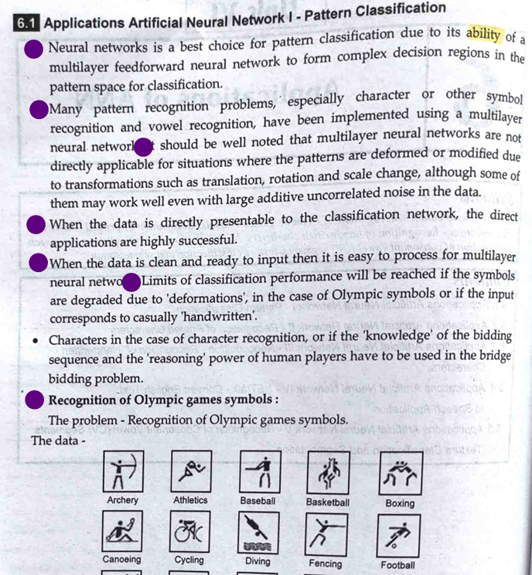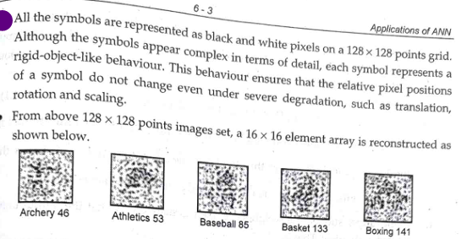

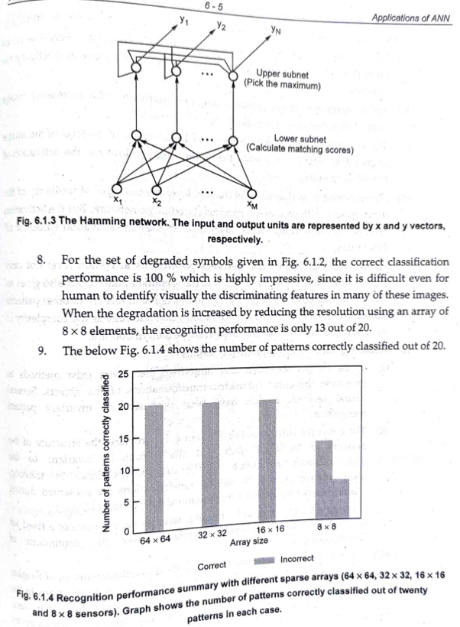

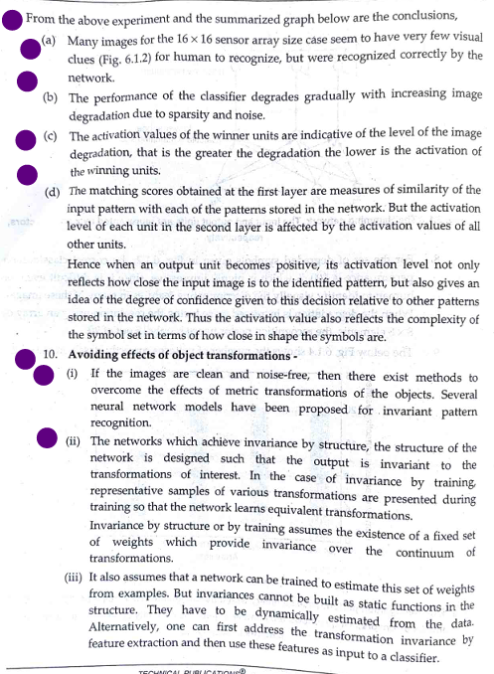

**examples of pattern recognition in everyday life**

1. **Facial Recognition**: Identifying friends and family members by their faces.

2. **Voice Recognition**: Recognizing someone's voice over the phone.

3. **Reading and Language Comprehension**: Understanding text and spoken language.

4. **Music Recognition**: Identifying a song or melody.

5. **Traffic Signals and Road Signs**: Recognizing and responding to traffic lights and road signs while driving.

6. **Daily Routines and Schedules**: Following a daily routine, such as getting ready for work.

7. **Pattern Recognition in Nature**: Identifying weather patterns.

8. **Financial Transactions**: Recognizing spending patterns from bank statements.

9. **Learning and Education**: Identifying patterns in mathematical problems.

10. **Health and Medicine**: Recognizing symptoms of an illness.

11. **Shopping and Consumer Behavior**: Identifying products and brands by their logos and packaging.

12. **Security and Authentication**: Using biometric systems like fingerprint or facial recognition for security.

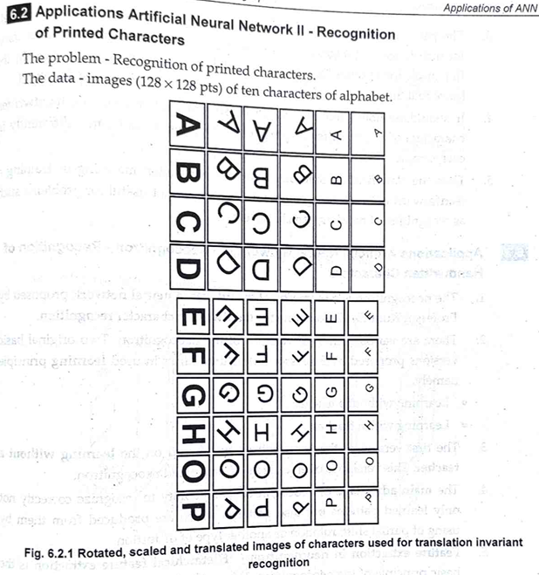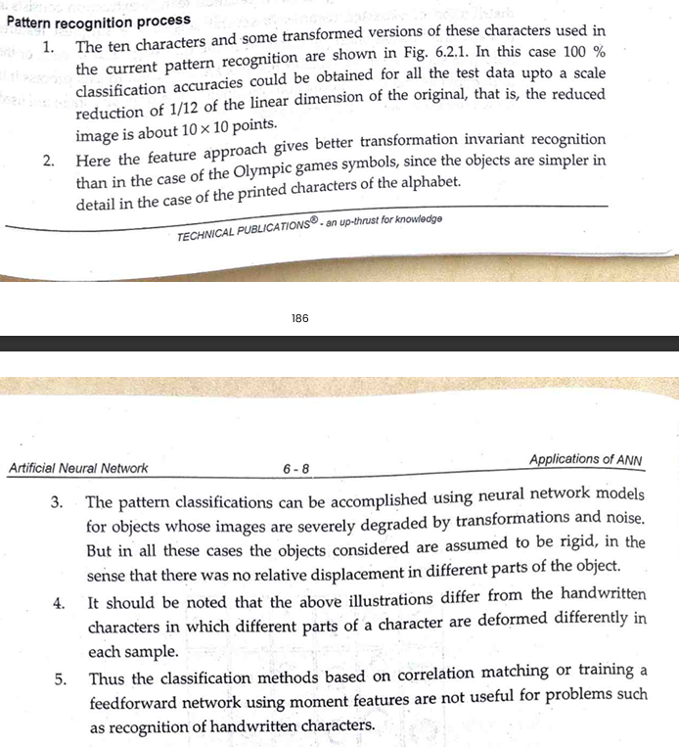

Scale reduction -> 1/12 of linear dimensions of original (reduced image become 10 x 10 points)

Better transformation invariant recognition than Olympic games

Images degraded by transformation and noise but in all cases, object considered are assumed rigid

Differ form handwritten as in HW characters are deformed differently In each sample

Different because it is unlike hw recognition as it has different hw styles. A pattern recognition algorithm is translation invariant if it can correctly identify objects or patterns regardless of their position within an image. So that correlation model are not for hw characters.

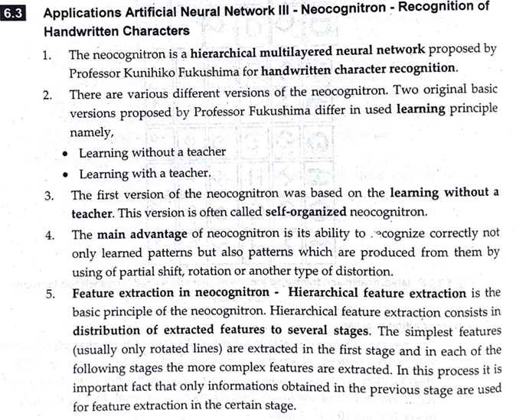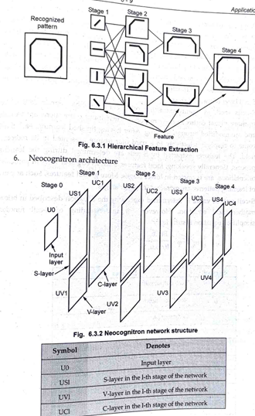

Optional:

The Neocognitron is a type of artificial neural network, initially proposed by Kunihiko Fukushima in 1980, primarily designed for pattern recognition tasks, particularly in the domain of image processing. It was inspired by the structure and functionality of the visual cortex in the brain. The Neocognitron laid the groundwork for modern convolutional neural networks (CNNs) and significantly influenced the development of deep learning algorithms for image recognition tasks.

**Structure of the Neocognitron:**

1. **Hierarchical Architecture**:
   * The Neocognitron consists of multiple layers of neurons organized in a hierarchical manner.
   * Each layer processes input data and extracts increasingly complex features.
2. **S-Cells and C-Cells**:
   * **S-Cells (Simple Cells)**: These cells detect specific features within a local receptive field. They respond to various shapes, edges, or textures in the input data.
   * **C-Cells (Complex Cells)**: These cells integrate the responses of multiple S-cells to achieve invariance to slight shifts, distortions, and changes in the input. They help in pooling and generalizing features extracted by S-cells.
3. **Interconnections**:
   * Neurons in different layers are interconnected with variable connection weights, which are learned during the training process.
   * The network adapts to recognize patterns by adjusting these weights through a process known as backpropagation.

**1. **S-Layer (Simple Layer)**:**

- The S-layer, also known as the simple layer, is the first layer in the Neocognitron's hierarchy.

- Each neuron in the **S-layer is connected to a small local receptive field in the input image**.

- **S-layer neurons act as feature detectors, responding to specific patterns or features within their receptive fields, such as edges, corners, or textures.**

- The responses of S-layer neurons are typically computed using convolutional operations followed by nonlinear activation functions.

- The S-layer is **responsible for extracting low-level features** from the input image.

**2. **C-Layer (Complex Layer)**:**

- The C-layer, or complex layer, follows the S-layer in the Neocognitron's hierarchy.

**- Neurons in the C-layer are connected to multiple neurons in the preceding S-layer, representing larger receptive fields.**

- C-layer neurons **integrate the responses of multiple S-layer neurons,** **pooling and combining the features detected at the previous layer.**

- By integrating features from multiple S-layer neurons, C-layer neurons achieve a degree of invariance to variations such as shifts, distortions, and changes in scale.

- The C-layer plays a **crucial role in capturing higher-level features** and patterns composed of the low-level features detected by the S-layer.

**3. **V-Layer (Vector Layer)**:**

- The V-layer, also known as the vector layer, is typically the final layer in the Neocognitron's hierarchy.

- Neurons in the V-layer are **fully connected to neurons in the preceding C-layer**.

- V-layer neurons **perform classification or recognition based on the features extracted and combined by the preceding layers.**

- Each neuron in the V-layer **represents a category or class that the Neocognitron aims to recognize.**

- During training, the connections and weights between C-layer neurons and V-layer neurons are adjusted using supervised learning techniques to optimize the network for specific recognition tasks.

In summary, the **S-layer detects low-level features, the C-layer combines and integrates these features to achieve invariance, and the V-layer performs classification based on the extracted features**, collectively enabling the Neocognitron to recognize patterns and objects in input images.

What is neocognitron neural network and how it is trained?

**The Neocognitron is a hierarchical**, multi-layered artificial neural network designed for pattern recognition tasks, particularly for images. It was introduced by Kunihiko Fukushima in 1980 and was inspired by the structure and function of the visual cortex in the brain. The Neocognitron laid the foundation for modern convolutional neural networks (CNNs).

### Structure of the Neocognitron:

1. **Hierarchical Architecture**:

- The Neocognitron consists of multiple layers of neurons arranged hierarchically.

- Each layer processes input data and extracts increasingly complex features.

2. **S-Cells and C-Cells**:

- **S-Cells (Simple Cells)**: These cells detect specific features within a local receptive field. They respond to various shapes, edges, or textures in the input data.

- **C-Cells (Complex Cells)**: These cells integrate the responses of multiple S-cells to achieve invariance to slight shifts, distortions, and changes in the input. They help in pooling and generalizing features extracted by S-cells.

3. **Interconnections**:

- The neurons are interconnected with variable connection weights, which are learned during the training process.

- The network adapts to recognize patterns by adjusting these weights through a process known as backpropagation.

**### Training of the Neocognitron:**

1. **Initialization**:

- The weights of the connections between neurons are initialized randomly or using specific initialization techniques.

2. **Forward Propagation**:

- During training, an input image is fed forward through the network layer by layer.

- At each layer, the input is convolved with learnable filters, and the resulting activations are passed through a nonlinear activation function (e.g., sigmoid or ReLU).

- This process continues through the layers until the output layer is reached, producing a prediction for the input.

3. **Error Calculation**:

- The output of the network is compared to the true label of the input image to calculate the error.

- Various loss functions can be used to quantify the difference between the predicted output and the actual label (e.g., cross-entropy loss for classification tasks).

4. **Backpropagation**:

- The error is propagated backward through the network using the chain rule of calculus.

- The gradients of the error with respect to the network's parameters (i.e., weights and biases) are computed.

- These gradients are used to update the parameters using optimization algorithms such as stochastic gradient descent (SGD) or Adam.

5. **Weight Updates**:

- The weights and biases of the network are adjusted in the direction that minimizes the error, effectively "learning" from the training data.

- This process iterates over the entire training dataset multiple times (epochs) until the network's performance converges or reaches a satisfactory level.

### Conclusion:

The Neocognitron is a pioneering neural network model for pattern recognition, especially in images. Its hierarchical architecture and training process paved the way for the development of modern CNNs, which are widely used in various applications such as image classification, object detection, and image generation. By learning from examples and adapting its internal parameters, the Neocognitron demonstrates the power of neural networks in recognizing and understanding complex patterns in data.

**You have been asked to develop a model of recognizing hand written digits. What are the chosen steps for activity? Explain each with detail**

### Step 1: Data Collection and Preparation

1. **Data Gathering**:

- Acquire a diverse dataset containing images of handwritten digits.

- Ensure the dataset covers a wide range of writing styles, sizes, and orientations.

2. **Data Preprocessing**:

- Normalize the images by scaling the pixel values to a range (e.g., [0, 1]).

- Resize the images to a uniform size (e.g., 28x28 pixels).

- Apply techniques like noise reduction, contrast adjustment, and image augmentation to enhance the dataset's quality and variety.

### Step 2: Model Selection

1. **Choose Model Architecture**:

- Select an appropriate model architecture capable of learning and recognizing patterns in images.

- Consider using a Convolutional Neural Network (CNN) due to its effectiveness in image recognition tasks.

2. **Design Model Architecture**:

- Design a CNN architecture consisting of convolutional layers, pooling layers, and fully connected layers.

- Experiment with different architectures and hyperparameters to find the optimal configuration for the task.

### Step 3: Model Training

1. **Dataset Splitting**:

- Divide the dataset into training, validation, and testing sets to evaluate the model's performance.

2. **Training Process**:

- Train the model on the training set using optimization algorithms like stochastic gradient descent (SGD) or Adam.

- Update the model's parameters (weights and biases) iteratively to minimize a chosen loss function (e.g., categorical cross-entropy).

- Experiment with different learning rates, batch sizes, and regularization techniques to optimize the model's performance and prevent overfitting.

### Step 4: Model Evaluation

1. **Validation Set Evaluation**:

- Periodically evaluate the model's performance on the validation set during training to monitor its progress and identify potential overfitting.

2. **Testing Set Evaluation**:

- Evaluate the final trained model on the unseen testing set to obtain an unbiased estimate of its performance.

- Measure metrics such as accuracy, precision, recall, and F1-score to assess its effectiveness in recognizing handwritten digits.

### Step 5: Model Deployment

1. **Integration**:

- Integrate the trained model into an application or system where handwritten digits need to be recognized.

- Consider digit recognition apps or automated form processing systems as potential deployment scenarios.

2. **Optimization**:

- Optimize the model for inference by reducing its size, leveraging hardware acceleration, and implementing techniques like model quantization or pruning to improve efficiency.

3. **Continuous Monitoring and Updates**:

- Monitor the model's performance in production and update it periodically with new data or retraining to adapt to changes in handwriting styles or input distributions.

By following these step-by-step instructions, you can develop an effective model for recognizing handwritten digits, capable of accurately identifying and classifying digit images in various real-world scenarios.

**Describe the Neocognitron model and its significance in the recognition of handwritten characters**

The Neocognitron, introduced by Kunihiko Fukushima in 1980, is a hierarchical, multi-layered artificial neural network designed for visual pattern recognition tasks, particularly those involving images, such as handwritten character recognition. The architecture of the Neocognitron is inspired by the human visual system,

### Structure of the Neocognitron

The Neocognitron is composed of multiple layers of neurons organized in a hierarchical manner, which include:

1. **Input Layer**:

- This layer receives the raw input image data, which typically consists of pixel values.

2. **S-Layers (Simple Layers)**:

- S-layers are responsible for detecting basic features in the input image, such as edges or textures. Each neuron in an S-layer responds to specific patterns within its local receptive field.

- The neurons in S-layers perform convolution-like operations, detecting features from small regions of the input image.

3. **C-Layers (Complex Layers)**:

- C-layers pool the outputs of the S-layers, providing a degree of shift and distortion invariance. This means that the C-layers can recognize features regardless of their exact position in the input image.

- Neurons in the C-layers integrate the responses of multiple S-layer neurons, effectively capturing higher-level features and patterns.

4. **V-Layers (Vector Layers)**:

- V-layers are typically found at the top of the hierarchy and are responsible for the final classification or recognition tasks.

- Neurons in the V-layers receive inputs from the C-layers and make decisions based on the combined features detected in the previous layers.

### Significance in the Recognition of Handwritten Characters

The Neocognitron's significance in the recognition of handwritten characters lies in its innovative approach to feature extraction and its ability to handle variations in handwriting. Here are some key points highlighting its importance:

1. **Hierarchical Feature Extraction**:

- The Neocognitron's multi-layered structure allows it to extract features at different levels of abstraction. Lower layers detect simple features like edges, while higher layers combine these features to recognize more complex patterns and shapes.

2. **Shift and Distortion Invariance**:

- The inclusion of C-layers enables the Neocognitron to achieve invariance to shifts and small distortions in the input images. This is particularly important for handwritten character recognition, as characters may vary in position and shape.

3. **Robustness to Variations**:

- Handwritten characters can exhibit significant variations due to different writing styles, sizes, and orientations. The Neocognitron's architecture is designed to be robust to such variations, making it well-suited for recognizing handwritten text.

4. **Unsupervised Learning**:

- Early versions of the Neocognitron used unsupervised learning for feature extraction, allowing the network to adapt to new patterns without requiring extensive labeled data. This capability is advantageous in scenarios where labeled training data is limited.

5. **Inspiration for Modern CNNs**:

- The Neocognitron laid the groundwork for the development of convolutional neural networks (CNNs), which are now the standard for image recognition tasks. Concepts like convolutional layers, pooling, and hierarchical feature extraction in CNNs are derived from the Neocognitron's architecture.

### Conclusion

The Neocognitron represents a pioneering model in the field of pattern recognition and neural networks. Its hierarchical structure and ability to handle variations in input data make it particularly effective for tasks like handwritten character recognition. By inspiring the development of modern CNNs, the Neocognitron has had a lasting impact on the field of computer vision and artificial intelligence.

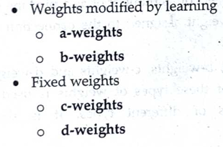

a= c -> s c=c -> v

b= v -> s d=s -> c

**NETtalk.**

It was designed to learn to pronounce written English text, essentially converting text to speech. This project is significant because it demonstrated the potential of neural networks to learn complex mappings from input to output without explicit programming, showcasing the power of machine learning in natural language processing.

### Structure and Mechanism

NETtalk consists of several key components:

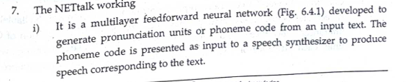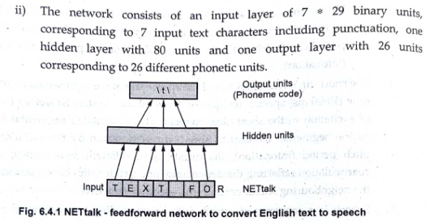

1. **Input Layer**: The input to the network consists of a sliding window of seven letters. The window is centered on the letter to be pronounced, with three letters of context on either side.

2. **Hidden Layer**: The input layer is connected to a single hidden layer of neurons. The hidden layer processes the input patterns and extracts relevant features needed for pronunciation.

3. **Output Layer**: The output layer produces a phoneme corresponding to the central letter of the input window. Phonemes are the basic units of sound in speech.

### Training Mechanism

NETtalk was trained using a supervised learning approach. The training data consisted of pairs of input (text) and output (phoneme) examples. The network was trained using backpropagation, a common algorithm for training neural networks by minimizing the error between the predicted output and the actual phoneme.

**Texture Classification:**

Texture classification is a fundamental task in computer vision and image processing, aiming to categorize images based on their textural patterns. Textures refer to the visual patterns on surfaces that are characterized by the spatial distribution of intensities or colors, and they provide important information about the surface properties and the structure of objects.

### Modern Approaches with Deep Learning

With the advent of deep learning, Convolutional Neural Networks (CNNs) have become the dominant approach for texture classification due to their ability to learn hierarchical representations directly from raw images:

- **Convolutional Neural Networks (CNNs)**: CNNs automatically learn features from images through a series of convolutional layers, pooling layers, and fully connected layers. Pre-trained networks like VGG, ResNet, and others have been successfully applied to texture classification tasks.

- **Transfer Learning**: Transfer learning involves fine-tuning a pre-trained CNN on a specific texture dataset, leveraging the learned features from large-scale datasets to improve performance on texture classification.

- **Deep Texture Encoding Networks**: These networks combine traditional texture descriptors with deep learning by integrating encoding layers that capture textural information, enhancing the representation capability of CNNs for texture analysis.

**Explain texture classification using convolution neural network.**

Texture classification using Convolutional Neural Networks (CNNs) involves training a deep learning model to automatically recognize and categorize textures in images. CNNs are particularly well-suited for this task due to their ability to learn hierarchical features directly from raw pixel data, capturing both local patterns and more abstract representations.

### Key Concepts of CNNs for Texture Classification

1. **Convolutional Layers**:

- **Convolution Operations**: Convolutional layers apply a series of filters (kernels) across the input image to create feature maps. Each filter detects specific local patterns such as edges, textures, or colors.

- **Receptive Fields**: The receptive field is the region of the input image to which a particular feature detector is sensitive. In texture classification, small receptive fields in initial layers capture fine textures, while larger receptive fields in deeper layers capture more complex patterns.

2. **Pooling Layers**:

- **Downsampling**: Pooling layers reduce the spatial dimensions of the feature maps, retaining the most essential features while reducing computational complexity. Common pooling operations include max pooling and average pooling.

3. **Activation Functions**:

- **Non-linearity**: Activation functions like ReLU (Rectified Linear Unit) introduce non-linearity into the network, allowing it to learn more complex patterns and representations.

4. **Fully Connected Layers**:

- **High-Level Reasoning**: After a series of convolutional and pooling layers, fully connected layers interpret the extracted features for final classification. These layers connect every neuron in one layer to every neuron in the next layer.

5. **Output Layer**:

- **Classification**: The output layer typically uses a softmax activation function for multi-class classification, providing the probability distribution over the different texture classes.

### Steps in Texture Classification Using CNNs

1. **Data Preparation**:

- **Dataset Collection**: Gather a large dataset of labeled texture images representing different classes.

- **Preprocessing**: Normalize the images, resize them to a consistent size, and augment the data through transformations like rotations, flips, and color adjustments to improve model robustness.

2. **Model Design**:

- **Architecture Selection**: Design a CNN architecture suitable for the complexity of the texture classification task. Common architectures include simple sequential models or more complex ones like VGG, ResNet, or Inception.

- **Hyperparameters**: Choose appropriate hyperparameters, including the number of layers, filter sizes, learning rate, and batch size.

3. **Training**:

- **Loss Function**: Use a suitable loss function, typically categorical cross-entropy for multi-class classification.

- **Optimization Algorithm**: Employ an optimization algorithm like Adam, SGD, or RMS prop to minimize the loss function.

- **Training Process**: Train the network on the training dataset, adjusting weights through backpropagation to minimize the loss.

4. **Evaluation**:

- **Validation and Testing**: Evaluate the trained model on validation and test datasets to ensure it generalizes well to unseen data.

- **Performance Metrics**: Use metrics like accuracy, precision, recall, and F1-score to assess the model's performance.

5. **Fine-Tuning and Transfer Learning**:

- **Fine-Tuning**: Adjust the model by fine-tuning hyperparameters or network layers based on validation performance.

- **Transfer Learning**: Leverage pre-trained models on large datasets (e.g., ImageNet) and fine-tune them on the specific texture classification dataset to improve performance with less training data.

**Which device recognize a pattern of handwritten or printed characters? And also illustrate it’s working.**

A device that recognizes patterns of handwritten characters is often referred to as an Optical Character Recognition (OCR) device. OCR devices are used to convert handwritten or printed text into digital text, allowing computers to process, analyze, and manipulate the text data.

### Working Principle of OCR Devices for Handwritten Characters

1. **Image Acquisition**: The process begins with capturing an image of the handwritten characters using a scanner, camera, or other imaging devices.

2. **Preprocessing**:

- **Noise Removal**: The acquired image may contain noise or artifacts that can interfere with recognition. Preprocessing techniques like smoothing filters or thresholding are applied to clean the image.

- **Image Enhancement**: Enhancements such as contrast adjustment, sharpening, or binarization may be performed to improve the quality and readability of the characters.

3. **Feature Extraction**:

- **Segmentation**: The image is segmented into individual characters or regions of interest. This step separates each character from the rest of the image.

- **Feature Extraction**: Features such as shape, size, texture, and spatial distribution of pixels are extracted from each segmented character. These features help characterize the handwriting style and distinguish between different characters.

4. **Pattern Recognition**:

- **Classifier Training**: A machine learning model or pattern recognition algorithm is trained using a dataset of handwritten characters. The model learns to identify patterns and associations between the extracted features and the corresponding characters.

- **Character Recognition**: During recognition, the extracted features of each segmented character are compared to the learned patterns in the classifier. The classifier assigns a probability or confidence score to each character class, indicating the likelihood of the observed features belonging to that class.

- **Decision Making**: The character with the highest probability or confidence score is selected as the recognized character for that segment.

5. **Post-Processing**:

- **Error Correction**: Post-processing techniques may be applied to correct recognition errors, such as using context-based language models or spell-checking algorithms.

- **Output Formatting**: The recognized characters are converted into digital text format and may be further processed or displayed as needed.

### Types of OCR Devices for Handwritten Characters

1. **Desktop OCR Software**: These are software applications installed on computers or mobile devices, such as Adobe Acrobat, ABBYY FineReader, or Tesseract OCR. They provide a user-friendly interface for scanning and recognizing handwritten or printed text.

2. **Mobile OCR Apps**: Mobile applications available on smartphones or tablets that allow users to capture images of handwritten text using the device's camera and convert it into digital text. Examples include Google Keep, Microsoft Office Lens, and Evernote.

3. **Handheld OCR Scanners**: Portable devices designed specifically for scanning and recognizing text from documents, receipts, or handwritten notes. These devices often have built-in OCR capabilities and may offer features like text-to-speech conversion.

4. **Embedded OCR Systems**: OCR functionality integrated into other devices or systems, such as document scanners, photocopiers, or multifunction printers. These devices can automatically recognize text as part of their scanning or copying process.

### Conclusion

OCR devices for recognizing handwritten characters utilize a combination of image processing, feature extraction, pattern recognition, and machine learning techniques to convert handwritten text into digital format. By leveraging advanced algorithms and models, these devices enable efficient digitization of handwritten documents, facilitating tasks such as data entry, document indexing, and text analysis.

**What is automatic translation? How does it work? What are its benefits**

Automatic translation, also known as machine translation, is the process of using computer algorithms and software to translate text or speech from one language to another without human intervention. It aims to bridge language barriers and facilitate communication between people who speak different languages.

### Working Principle of Automatic Translation

1. **Data Collection and Corpus Building**:

- Automatic translation systems rely on vast amounts of bilingual text data, known as parallel corpora, which consist of pairs of sentences or documents in two or more languages.

- These corpora are used to train machine learning models and statistical algorithms that learn the associations and patterns between words and phrases in different languages.

2. **Model Training**:

- Machine learning models, such as neural networks or statistical models, are trained using the parallel corpora to learn the mapping between source and target languages.

- Neural machine translation (NMT) models, in particular, have gained popularity due to their ability to learn complex patterns and dependencies in language data.

3. **Feature Extraction**:

- The input text in the source language is tokenized and converted into a numerical representation, often using techniques like word embeddings or one-hot encoding.

- The model extracts features from the source text, capturing information about the meaning, context, and syntactic structure of the text.

4. **Translation Process**:

- The extracted features are fed into the trained translation model, which generates a sequence of tokens representing the translation in the target language.

- The model utilizes its learned knowledge to predict the most probable translation based on the input features and the associations learned during training.

5. **Post-Processing**:

- The generated translation may undergo additional processing steps, such as language model integration, reordering, or grammatical correction, to improve fluency and accuracy.

- Post-editing by human translators may also be employed to refine the translation and ensure quality in professional translation settings.

### Benefits of Automatic Translation

1. **Facilitating Communication**: Automatic translation enables individuals and organizations to communicate effectively across language barriers, fostering collaboration, understanding, and cultural exchange on a global scale.

2. **Time and Cost Efficiency**: Compared to manual translation by human translators, automatic translation can be performed quickly and at a lower cost, especially for large volumes of text or real-time translation needs.

3. **Scalability and Accessibility**: Automatic translation systems can handle a wide range of languages and translation tasks, making them accessible to users worldwide and applicable in diverse contexts, such as business, travel, and education.

4. **Consistency and Standardization**: Automatic translation systems ensure consistency in translations, reducing the risk of errors, inconsistencies, and variations in terminology that may occur with manual translation.

5. **Integration with Technology**: Automatic translation can be seamlessly integrated into various applications, platforms, and devices, including websites, mobile apps, chatbots, and virtual assistants, enhancing user experience and usability.

6. **Supporting Multilingual Content Creation**: Automatic translation tools assist content creators in reaching a global audience by enabling the translation of content into multiple languages efficiently and effectively.

### Conclusion

Automatic translation systems leverage machine learning algorithms and statistical models to translate text or speech between languages automatically. By facilitating communication, saving time and cost, and promoting accessibility and scalability, automatic translation plays a crucial role in breaking down language barriers and enabling global connectivity in today's interconnected world.

**Explain texture classification and segmentation in ANN:**

Texture classification and segmentation are important tasks in image processing and computer vision. They involve identifying patterns or regions within an image based on their texture properties. Artificial Neural Networks (ANNs) can be utilized for both tasks, albeit with different approaches.

1. **Texture Classification:**

- Texture classification involves categorizing an entire image or a region within an image into predefined classes based on its texture properties.

- ANNs can be used for texture classification by training a network to recognize patterns in the texture features extracted from images.

- Convolutional Neural Networks (CNNs) are particularly well-suited for texture classification tasks due to their ability to automatically learn hierarchical features from images.

- In CNN-based texture classification, the network typically consists of convolutional layers followed by pooling layers to extract features at different spatial scales. These features are then fed into fully connected layers for classification.

- During training, the network learns to map input texture features to corresponding class labels by adjusting its parameters (weights and biases) through backpropagation and optimization algorithms such as stochastic gradient descent (SGD).

2. **Texture Segmentation:**

- Texture segmentation involves partitioning an image into distinct regions or segments based on their texture properties.

- ANNs can be applied to texture segmentation tasks using various approaches, including supervised and unsupervised learning methods.

- In supervised texture segmentation with ANNs, the network is trained on a dataset where each image is annotated with ground truth segmentation masks. The network learns to predict segment boundaries or labels directly from input texture features.

- CNNs can also be adapted for unsupervised texture segmentation by incorporating techniques such as autoencoders or generative adversarial networks (GANs). These networks learn to represent and reconstruct input images, thereby implicitly capturing texture information. Subsequently, clustering algorithms or post-processing techniques can be applied to the network's latent representations to obtain texture segmentation results.

Overall, both texture classification and segmentation in ANN involve training neural networks to recognize and differentiate texture patterns in images, with classification focusing on assigning labels to entire images or regions, and segmentation focusing on partitioning images into distinct texture-based segments.

**Discuss the application of ANN in the recognition of consonant vowel (CV) segments**.

Artificial Neural Networks (ANNs) have been applied successfully in the recognition of consonant-vowel (CV) segments in various speech processing tasks. The recognition of CV segments is an essential step in speech processing systems, particularly in tasks such as speech recognition, speaker identification, and language understanding. Here's how ANNs are utilized in this context:

1. **Feature Extraction:**

- Before feeding the data into an ANN for CV recognition, relevant features need to be extracted from the speech signal. Common features include **Mel-frequency cepstral coefficients (MFCCs), linear predictive coding (LPC) coefficients, and spectrogram representations.**

- These features capture the temporal and spectral characteristics of the speech signal, which are crucial for distinguishing between different consonant and vowel sounds.

2. **ANN Architecture:**

- Once the features are extracted, they are fed into an ANN for classification.

- The architecture of the ANN can vary depending on the complexity of the task and the size of the dataset. Recurrent Neural Networks (RNNs), Convolutional Neural Networks (CNNs), or hybrid architectures like Convolutional Recurrent Neural Networks (CRNNs) are commonly used.

- For CV recognition, the ANN needs to learn the patterns in the feature representations that distinguish between different consonant and vowel sounds.

3. **Training:**

- The ANN is trained using supervised learning techniques. Training data typically consists of labeled examples of CV segments, where each segment is associated with its corresponding consonant and vowel labels.

- During training, the ANN learns to map the input feature representations to the correct consonant and vowel labels by adjusting its parameters (weights and biases) through backpropagation and optimization algorithms.

4. **Testing and Evaluation:**

- Once trained, the ANN is tested on unseen data to evaluate its performance in CV recognition.

- Performance metrics such as accuracy, precision, recall, and F1-score are commonly used to assess the effectiveness of the ANN in correctly identifying consonant and vowel segments.

5. **Application Areas:**

- The recognition of CV segments using ANNs finds applications in various speech-related tasks, including:

- Speech recognition: ANNs can be used to recognize spoken words and phrases by segmenting input speech signals into CV units.

- Speaker identification: ANNs can help identify speakers based on their pronunciation patterns, which include variations in CV segments.

- Language understanding: ANNs can assist in understanding spoken language by parsing input speech signals into meaningful linguistic units such as words and phonemes.

Overall, ANNs play a significant role in the recognition of CV segments in speech processing applications, enabling improved performance in tasks such as speech recognition, speaker identification, and language understanding.